Task 1 – Load Sample Data and Explore Power BI Views
Answer:
I opened Power BI Desktop and loaded the provided Sample Data Excel file using the Get Data option.
After loading the data, I explored the three main views of Power BI Desktop:
- Report View: Used to create reports and visualizations such as charts, tables, and dashboards.
- Data View: Used to view the loaded data in rows and columns.
- Model View: Used to view tables and understand the relationships between them.
I observed that each view provides a different way to work with and understand the data.

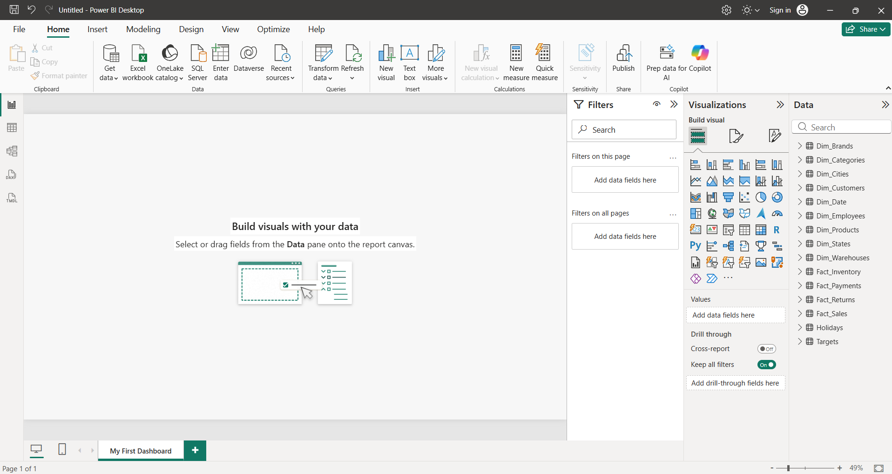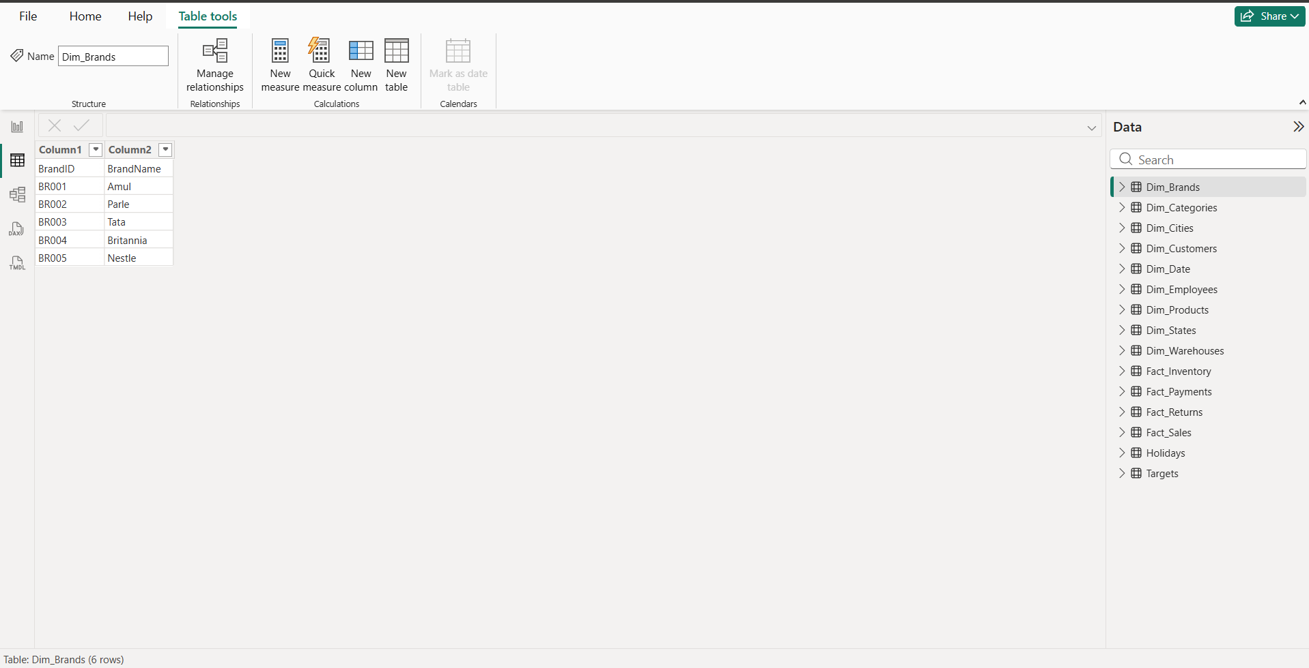
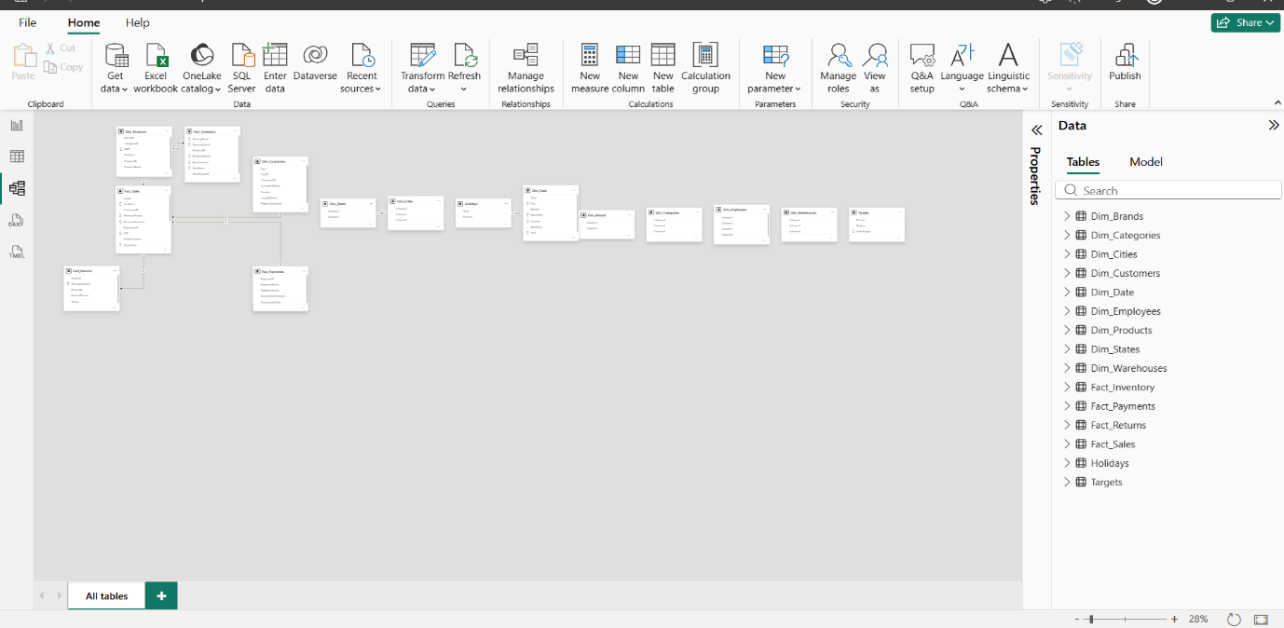

Task 2 – Create Two Different Visualizations
Answer:
I used the Fields (Data) Pane in Report View to create two separate visualizations using the Sample Data Excel file.
- Bar Chart: I created a bar chart to compare data using selected fields.
- Pie Chart: I created a pie chart to represent data distribution using selected fields.
Both visualizations were created successfully in Power BI Desktop.

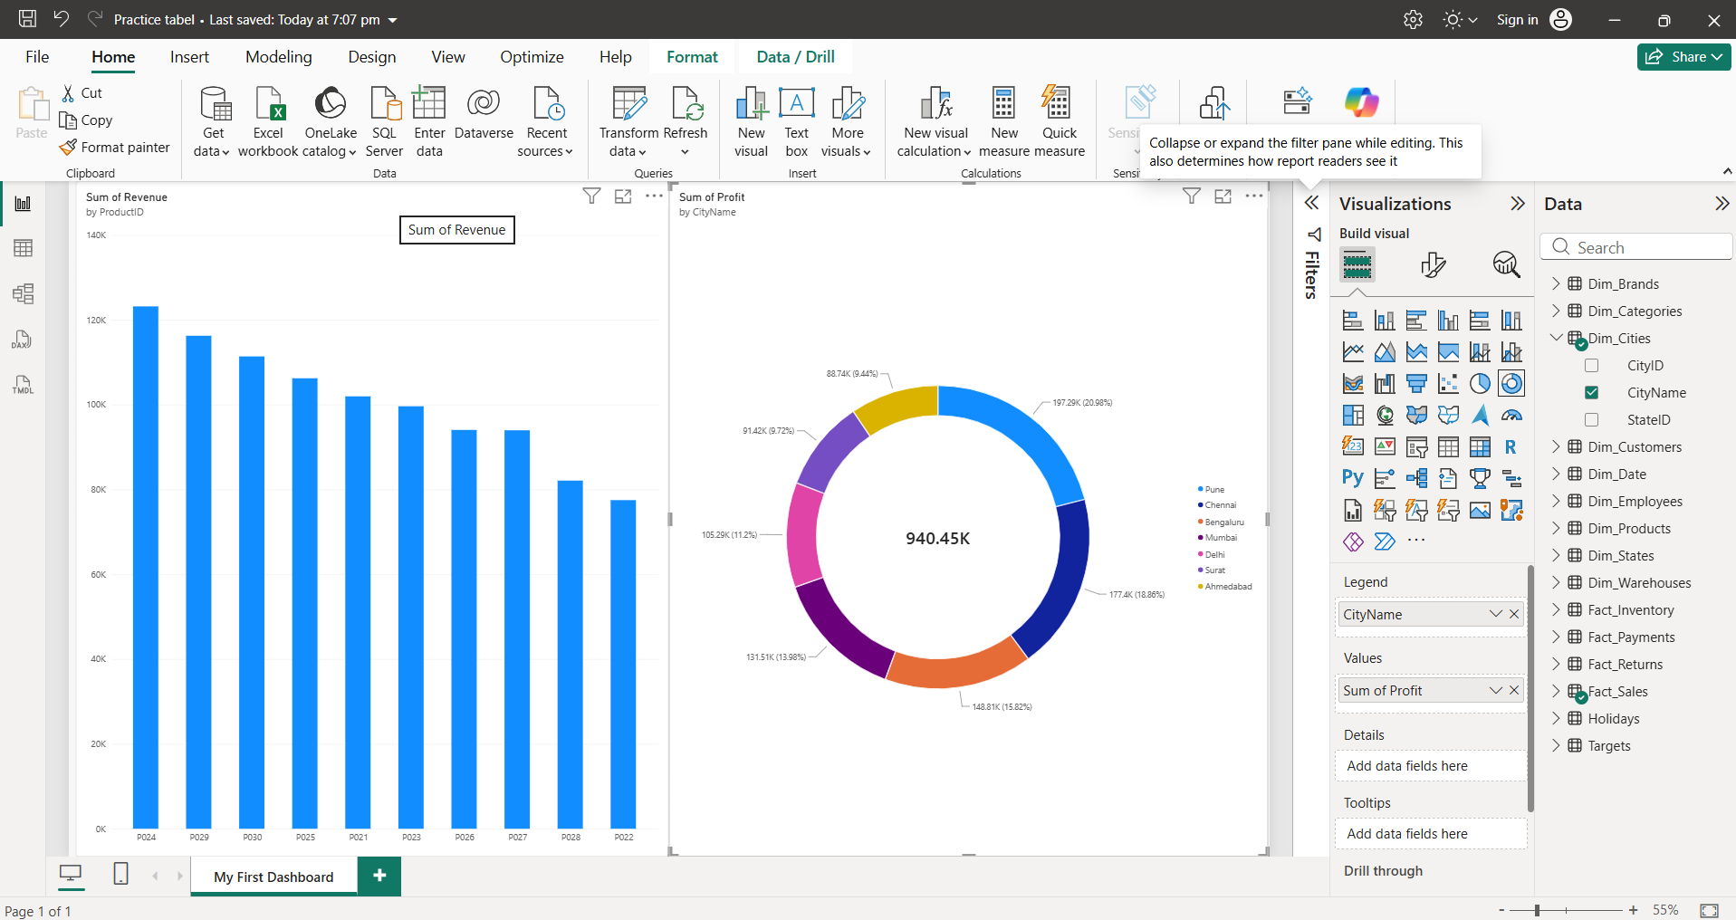

Task 3 – Apply a Filter Using the Filters Pane
Answer:
I used the Filters Pane in Power BI Desktop to filter the data.
I selected a specific value from the City/Category field using Basic Filtering.
After applying the filter, the visual displayed only the data related to the selected value.
This helped me understand how filters work in Power BI.

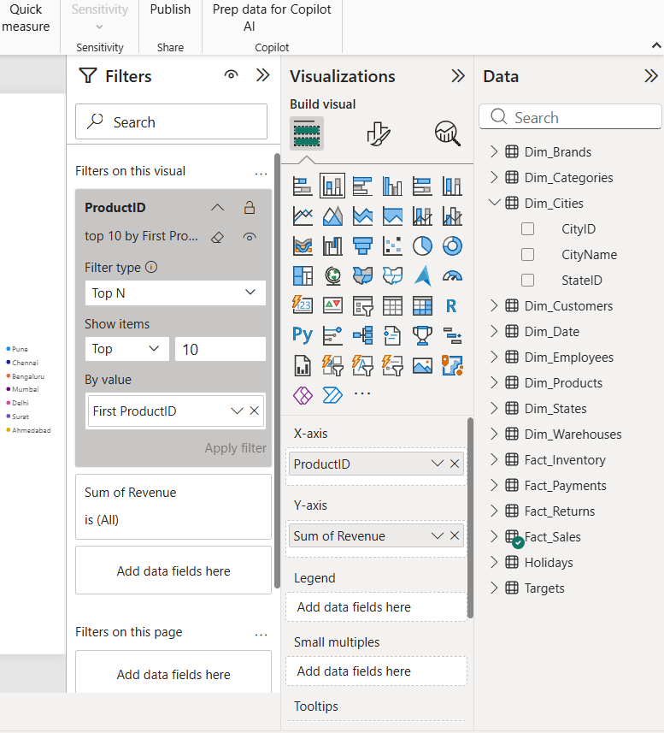

Task 4 – Explore Home and Insert Ribbon Commands
Answer:
I explored the Home and Insert tabs in Power BI Desktop.
- I used the New Page option to add a new report page.
- I used the Insert tab and selected Text Box.
- I inserted a text box and added my name, Alzar Memon.
This helped me understand how to add new pages and text boxes in Power BI.
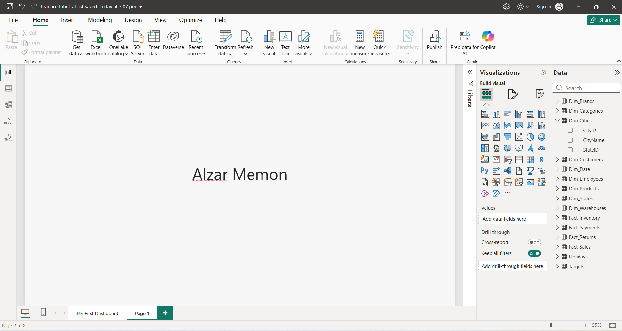

Task 5 – Explore Model View and Rename a Field
Answer:
I opened Model View in Power BI Desktop and explored the relationships between the tables.
I also selected a field from the Data Pane, right-clicked it, and used the Rename option to change its name.
For example, I renamed Cust_ID to Customer ID.
This helped me understand table relationships and field renaming in Power BI.



